**VV Styles User Guide:**

1. **Open VV Styles**

Open <https://ckiefer.pythonanywhere.com/>

Your browser window will look like this.

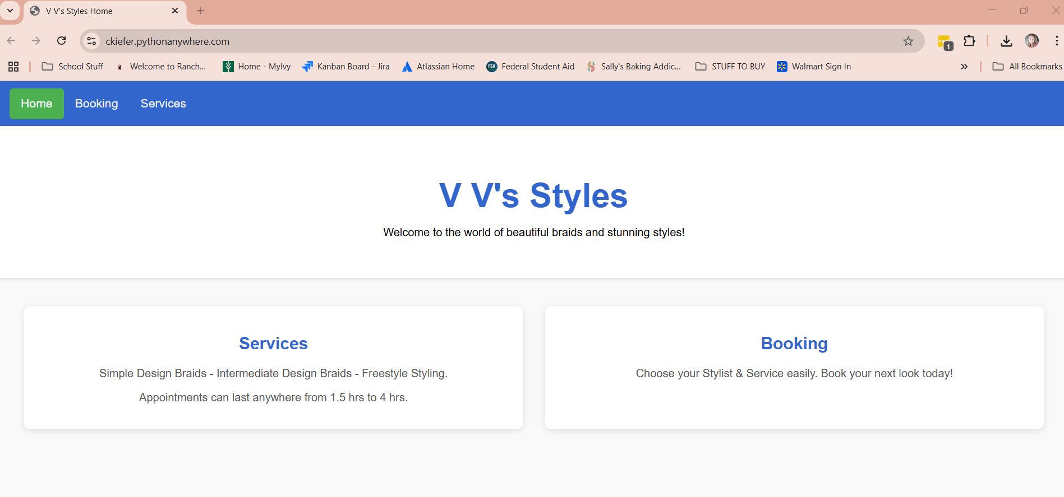

# **Click the “Services” link or the “Services” in the top bar to view braid styles.**

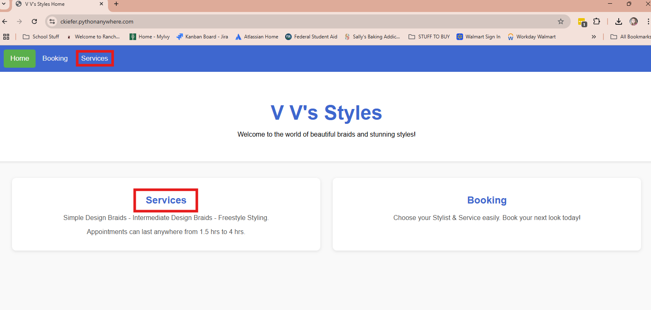

You will be brought to the “Services” page:

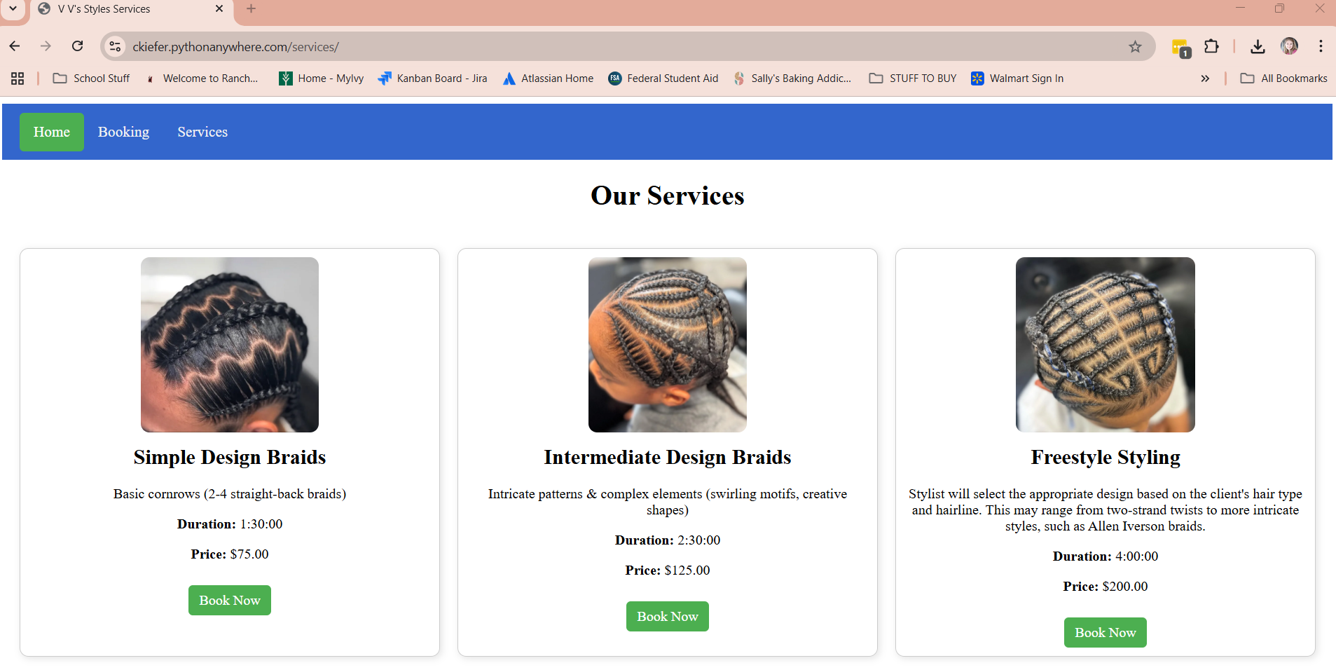

# **Then, either from the top bar in the “VV Styles Home” page, the “Booking” link from the “VV Styles Home” page, or the green button under the “VV Styles Services” page, you can book an appointment.**

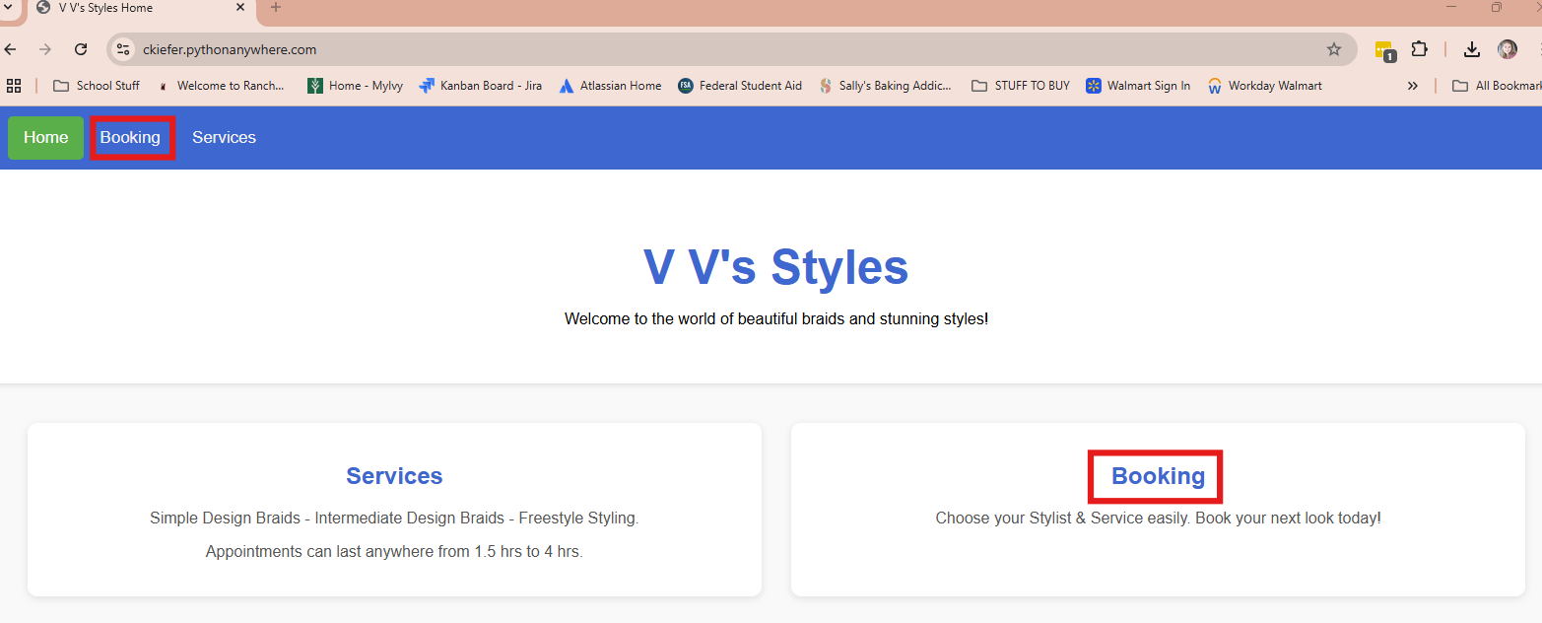

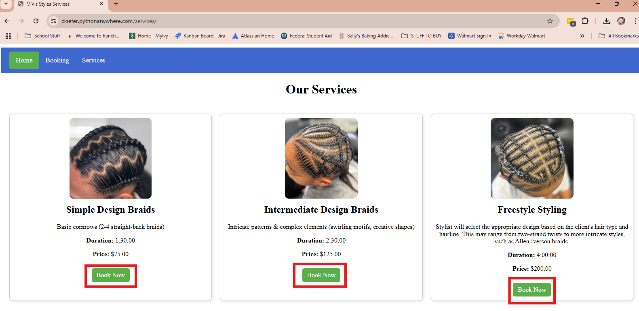

# **You will be brought to “Booking”**

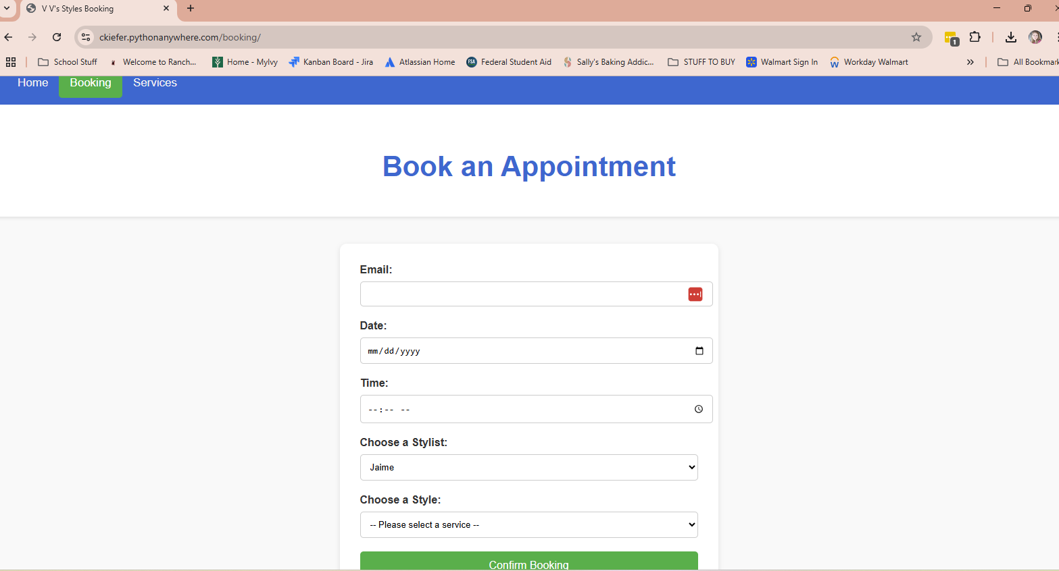

## **Email Entry**

Type your email in the email box

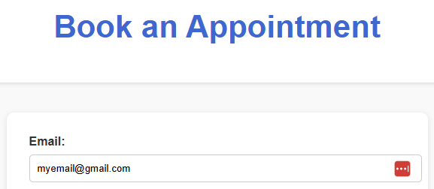

## **Date Entry**

Click the calendar icon on the right most of the “Date:” box and choose your date.

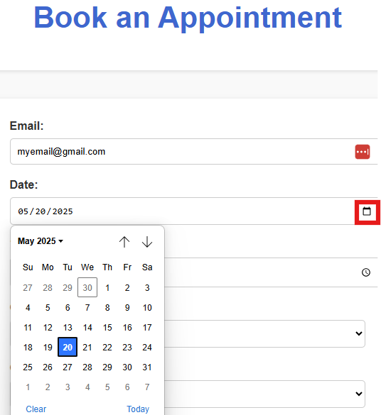

## **Time Entry**

Click the click icon on the right most of the “Time” box and scroll to select your preferred appointment time.

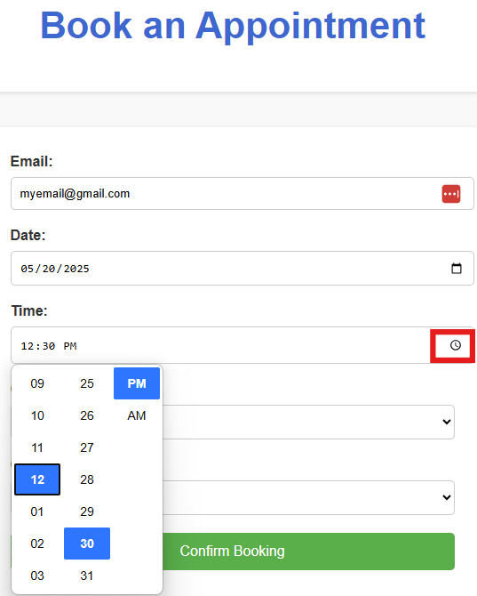

## **Stylist Drop Down**

Click on the arrow icon in the rightmost of the “Choose a Stylist:” box

Choose your preferred Stylist’s name.

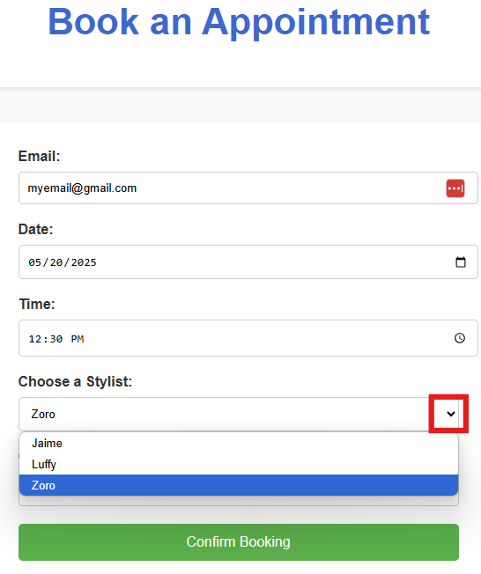

## **Style Drop Down**

Click on the arrow icon in the rightmost of the “Choose a Style:” box

Choose your preferred braid style.

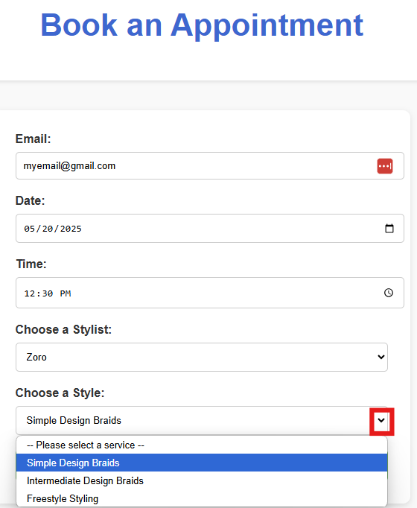

## **Confirm Booking**

Confirm your appointment by clicking the green “Confirm Booking” box.

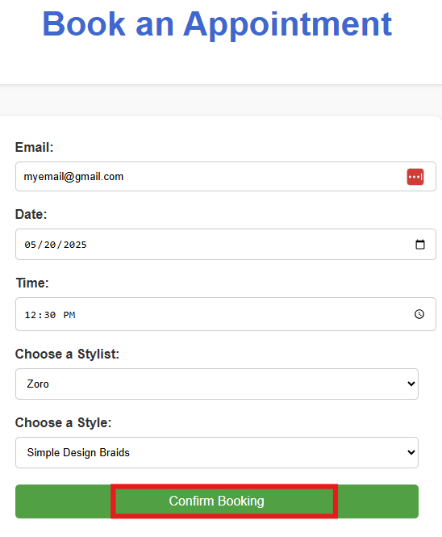

You will be brought to a “Booking Confirmed” page.

Your appointment has been booked!

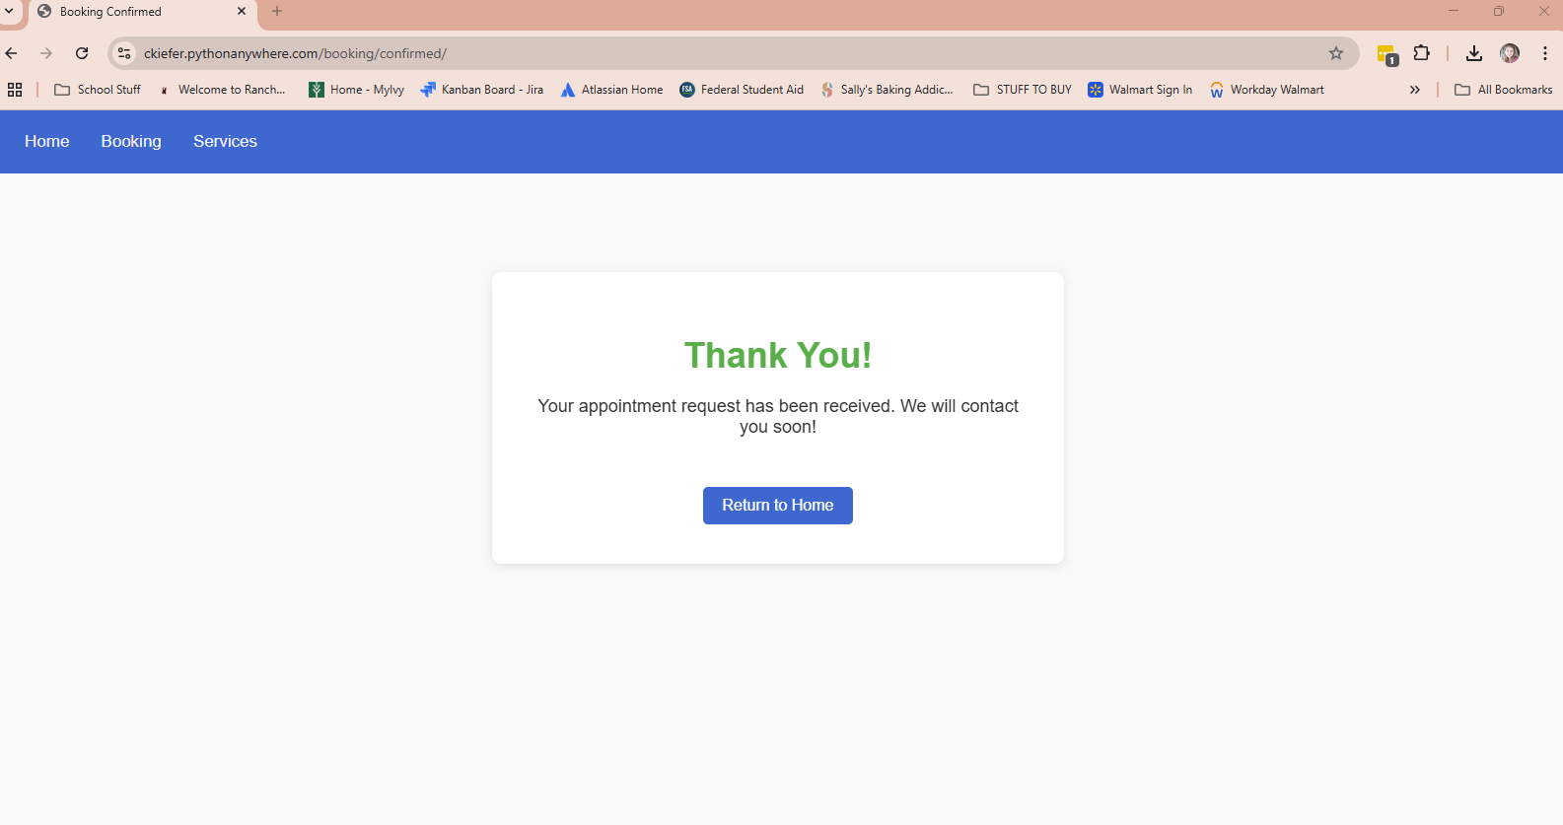

## **Exit VV Styles**

You may now click “Return to Home” to be brought back to VV Styles Homepage or exit the window.

